**Support**

**for**

**Veteran’s**

**What is a Veteran?**

Veterans are defined as **anyone who has served for at least one day in Her Majesty’s Armed Forces** (Regular or Reserve) or Merchant Mariners who have seen duty on legally defined military operations. A “Service Leaver” is a term for someone who is in transition from or has ceased to be a member of HM Armed Forces.

*Veterans Factsheet 2020–Gov.UK*

**Please find below information on some of the support services available.**

**Help for Heroes**

A British charity that provides comprehensive support to members of the British Armed Forces community. Their mission is to help veterans and their families live well after service. Here are some ways they offer assistance:

1. **Physical Healthcare Support**: Help for Heroes assists ill and injured veterans in getting the necessary treatment, regardless of whether the injury or illness is related to their military service.
2. **Mental Health Counselling**: They have a team of mental health professionals who provide tailored support to veterans and family members.
3. **Financial Grants**: The charity offers grants for home modifications, medical devices, and access to care. During the cost-of-living crisis, they’ve also helped with food and energy bills.
4. **Sport and Social Activities**: Help for Heroes organizes inclusive sporting and social activities across the UK for veterans and families.
5. **Welfare Support**: They assist veterans and families struggling with finances and living arrangements, including benefits entitlement and War Pension applications.
6. **Recovery College**: Free online courses cover topics like financial well-being, pain management, nutrition, anger management, and sleep improvement.

To get in touch call 0300 303 9888 or visit [**www.helpforheroes.org.uk**](http://www.helpforheroes.org.uk)

**Veterans Charity**

We can provide support to Veterans who find themselves battling hardship and the distress it causes. Despite being a small charity, we operate nationally throughout the UK including Northern Ireland. We are able to assist with essentials such as food shopping (including pet and baby products where required), utilities support, clothing and footwear, household items and single appliances, smartphones/tablets and calling credit/data.

The recipient of our support must be a Veteran of the UK Armed Forces who has completed a minimum of 6 months verifiable service, either as a regular or as a reservist. Verification of service will be required in order to obtain support.

For information and support visit [**www.veteranscharity.org.uk**](http://www.veteranscharity.org.uk)

**Forces Support** 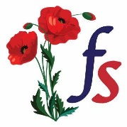

Our aim is to ensure that the parents, widows and children of families bereaved through a military death can access practical support throughout the UK and that they each have equal access to our support.

For information and support, call 07484 076727 or visit [**www.forcessupport.org.uk**](http://www.forcessupport.org.uk)

**Veterans Outreach Support**

Support veterans from the UK Armed Forces and Merchant Navy along with their spouses, partners and carers throughout Portsmouth, the Isle of Wight, Gosport, Fareham, and more widely, Hampshire and the south of England.

Provides access to welfare support, whether it be from PIP to housing and more.

VOS organises activities, events and social groups to promote camaraderie, community and fun.

VOS supports members via cognitive, behavioural and emotional wellbeing therapies and treatments.

Please call 02392 731767 or visit[**www.vosuk.org**](http://www.vosuk.org)

**Veterans Gateway**

The [Veterans’ Gateway](https://www.veteransgateway.org.uk/) is for any ex-service personnel and their families looking for advice or support – whatever they are dealing with. They provide the first point of contact to a network of military and non-military partner organisations to help you find exactly what you need, when you need it - whether you’re in the UK or overseas. For 24-hour support go to [**www.veteransgateway.org.uk**](http://www.veteransgateway.org.uk)

or call 0808 802 1212.

**NHS Operation Courage**

It’s an NHS service supported by trained professionals who are from, or have experience of working with, the armed forces community.

The service can help if you’re finding life difficult after leaving the military. Working together with armed forces charities, Op COURAGE will help you get the right type of specialist care, support and treatment for your specific needs.

We are in it together.

Please visit[**www.nhs.uk/nhs-services/armed-forces-community/mental-health/veterans-reservists/**](http://www.nhs.uk/nhs-services/armed-forces-community/mental-health/veterans-reservists/)

or call 0300 034 9986

**Royal British Legion**

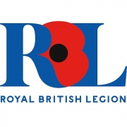Here to help members of the Royal Navy, British Army, Royal Air Force, Veterans and their families. Supporting serving and es-serving personnel all year round, every day of the week. Support starts after one day of service and continues through life, long after service is over.

**Please call 0808 802 8080 or visit** [**www.britishlegion.org.uk**](http://www.britishlegion.org.uk)

**Combat Stress** Provide clinical treatment and support for veterans from the British Armed Forces, with a focus on those with some of the most complex mental health issues. When some military personnel leave service, their experiences can’t easily be left behind. Without treatment, psychological trauma can eventually tear lives apart.

We believe military trauma shouldn’t destroy the lives of veterans and their families. For over a century, we’ve helped former servicemen and women with mental health problems such as post-traumatic stress disorder (PTSD), anxiety and depression.

Combat Stress is the UK's leading veterans' mental health charity, the work we do is life-changing and often life-saving. No one else does what we do. We provide the only intensive mental health treatment service to UK veterans. Our services are provided across the UK, in-person and online. At a time that can be isolating and daunting, we're here to help

**Please call 0800 138 1619 or visit** [**www.combatstress.org.uk**](http://www.combatstress.org.uk)

**SSAFA The Armed Forces Charity **

SSAFA helps the armed forces community in a number of ways, though our focus is on providing direct support to individuals in need of physical or emotional care.

Addiction, relationship breakdown, debt, homelessness, post-traumatic stress, depression and disability are all issues that can affect our members of our Armed Forces community. Many of these problems only become apparent when an individual has to leave their life in the Forces and join ‘Civvy Street’. SSAFA is committed to helping our brave men and women overcome these problems and rebuild their lives.

Please call 0800 260 6767 or visit [**www.ssafa.org.uk**](http://www.ssafa.org.uk)

**RNRMC**

The Royal Navy and Royal Marines Charity is the principal charity of the Royal Navy. Existing to support Sailors, Mariners and their families, for life.

Please call 02393 871520 or visit[www.rnrmc.org.uk](http://www.rnrmc.org.uk)

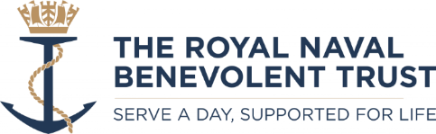**Royal Navy Benevolent Society**

Our main business is making grants/financial support to help those who are serving or have served as Warrant Officers and below in the Royal Navy and Royal Marines and their dependants who find themselves in difficulty.

Please call 02392 000996 or visit [www.rnbt.org.uk](http://www.rnbt.org.uk)

**Blind Veterans UK**

**Blind Veterans UK helps vision-impaired ex-Servicemen and women to rebuild their lives after sight loss.**

We provide rehabilitation, training, practical advice and emotional support to veterans regardless of how or when they lost their sight. We’re here to help blind veterans regain their independence and live the life they choose.

Visit - <https://www.blindveterans.org.uk>

Call – 0300 111 2233

**First Light Trust (Gosport)** e light going out.

Help stop the light going out. Putting Emergency Services and Armed Forces Veterans at the heart of what we do.

Support for

– Any veteran from the Armed Forces including Reservists and the Merchant Navy  
– Anyone who served in the Emergency Services  
– Any serviceman or woman who is about to leave or is leaving It doesn’t matter how long ago you left or in what circumstances: we are here to help.

How we can help

Some of the things we can sort out include:

– Housing  
– Making sure you have the right benefits, allowances and pensions  
– Supporting you to access the right medical treatment  
– Sorting out problems around debt  
– Support with drug and alcohol problems  
– Volunteering work  
– Writing CVs and getting you back to work

Visit -[**www.firstlighttrust.co.uk/gosport**](http://www.firstlighttrust.co.uk/gosport)

Call – 0207 730 7545

**Veterans Aid**

Veterans Aid’s Welfare to Wellbeing© model is one that looks at both context and the circumstances of the individual when tackling crisis. It introduces veterans to a system that will offer holistic support, but it recognises that some issues need to be resolved as a priority before others can be addressed.

Immediate actions might be provision of food, new clothing and shelter.

Subsequent interventions might involve prolonged periods of counselling, drink/drug rehabilitation and medical treatment.

Further support frequently involves education, retraining or the acquisition of a new skill.

Help is given to identify employment opportunities and, when they are considered ready, individuals are helped to move into new homes – furnished and decorated by Veterans Aid.

Welfare to Wellbeing© is the game-changer that accounts for Veterans Aid’s success and it goes a long way towards explaining why so many politicians, practitioners, academics and philanthropists involved in veterans affairs worldwide are looking beyond traditional benevolence towards a system that is multifaceted and integrated; a system that goes beyond welfare, towards sustainable ‘wellbeing’.

Call – 0800 012 6867

Visit – [www.veterans-aid.net](http://www.veterans-aid.net)

**The Poppy Factory**

If you’re part of the Armed Forces community and you feel your mental or physical health is making it hard to find employment, you can access free one-to-one support from The Poppy Factory. Our Employment Consultants work across England and Wales. We understand the difficulties veterans with health conditions can face, working to build their confidence and skills and find the right opportunities. Veterans can register for the employment service independently, or a referral can be made by any professional who is supporting a veteran with their mental or physical health needs.

Call 020 8940 3305

Visit – [www.poppyfactory.org](http://www.poppyfactory.org)

**Seafarers Advice and Information Line** 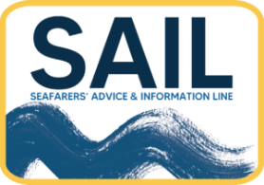

If you’ve ever worked at sea, then SAIL can help you and your partner. We can also help widows and widowers of seafarers and any dependants of seafarers.

If your organisation itself supports seafarers, then SAIL is here to help you too.

For Veterans we offer

* Benefits
* Charity Grants
* Pensions

Call – 0800 1601842

Or Visit[**www.sailine.org.uk**](http://www.sailine.org.uk)

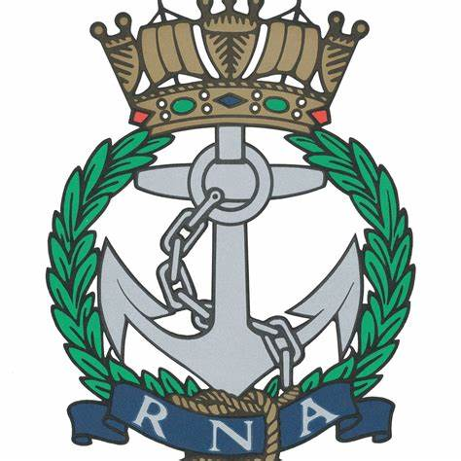**Royal Navy Association – Gosport**

The Royal Naval Association is committed to supporting Naval veterans, serving personnel and their families by offering community and guidance on a local, national and international level.

With a team of volunteers and full-time members of staff, we endeavour to help every member of our community when they are in need.

When times are tough, we can help you find the right support services.

Visit royal-naval-association.co.uk

Call – 02392 723747

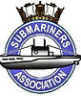**Gosport Submariners Association, Gosport**

The Gosport Branch of the Submariners Association is one of the biggest branches of the association.

We welcome all serving and retired RN submariners from across the country or abroad who wish to join us.

**Visit –** [**www.gosportsubmariners.com**](http://www.gosportsubmariners.com)

**Falklands Veterans Foundation**

A UK based charity for Falklands Veterans and their immediate families and is committed to providing a network of support and direction for those in need.

Available to point you in the right direction whether it is financial or to assist with any difficulties you are encountering.

Visit – info@falklandsveterans.org.uk

**Care After Combat**

Care after Combat is a UK based charity providing support within the Justice System for the well-being of former British Armed Forces personnel and their families.

Call 0300 343 0255

Visit – [www.careaftercombat.org](http://www.careaftercombat.org)

**Alabare Homes For Veterans**

Provides supported accommodation to British Armed Forces veterans who are homeless or at risk of becoming so. Support includes help with mental well-being and support accessing future employment.

Call 01722 322882

Visit – [www.homesforveterans.org.uk](http://www.homesforveterans.org.uk)

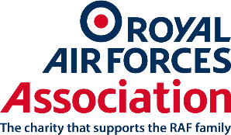**Royal Airforce Association, Fareham**

We support anyone who has had one day’s pay and one day’s service in the RAF, as well as their spouses, widows and dependants.

Visit – [www.rafa.org.uk](http://www.rafa.org.uk)

Call – 0800018 2361

**Are you registered at your GP?**

If you are a Veteran it is a good idea to inform your GP practice. This allows the surgery to provide you with more tailored care. Please complete the form below and pass to a member of the reception team.

Name:

Date of Birth:

Address:

Telephone:

Email:

What Service:

Date of leaving Armed Forces: